**Assignment -2**

Python Programming

|  |  |
| --- | --- |
| Assignment Date | 26 September 2022 |
| Student Name | Hariharan M |
| Student Roll Number | 312319104039 |
| Maximum Marks | 2 Marks |

# Question-1:

Download the dataset: Dataset

# Solution:

Downloaded successfully

**Question-2:** Load the dataset. **Solution:**

import pandas as pd

importnumpyas np

file=pd.read_csv("/content/Churn_Modelling (1).csv") df=pd.DataFrame(file) df.head()

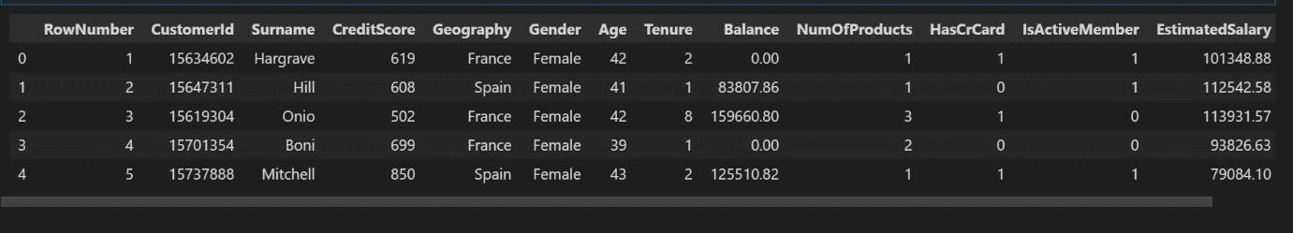

df['HasCrCard'] = df['HasCrCard'].astype('category')

df['IsActiveMember'] = df['IsActiveMember'].astype('category') df['Exited']

= df['Exited'].astype('category')

df = df.drop(columns=['RowNumber', 'CustomerId', 'Surname'])

df.head()

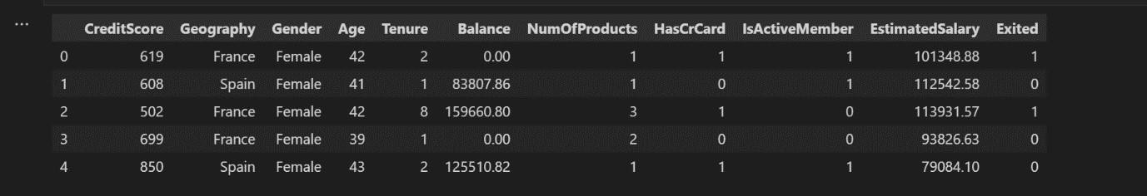

# Question 3:

Perform Below Visualizations:

Univariate Analysis, Bi - Variate Analysis, Multi - Variate Analysis

# Solution:

import seaborn assns

density = df['Exited'].value_counts(normalize=True).reset_index() sns.barplot(data=density, x='index', y='Exited', ); density

|  |  |  |
| --- | --- | --- |
|  | index | Exited |
| 0 | 0 | 0.7963 |
| 1 | 1 | 0.2037 |



The data is significantly imbalanced

importmatplotlib.pyplotasplt

categorical = df.drop(columns=['CreditScore', 'Age', 'Tenure', 'Balance', 'EstimatedSalary']) rows = int(np.ceil(categorical.shape[1] / 2)) - 1

# create sub-plots anf title them

fig, axes = plt.subplots(nrows=rows, ncols=2, figsize=(10,6)) axes

= axes.flatten()

for row inrange(rows):

cols = min(2, categorical.shape[1] - row*2) for col inrange(cols):

col_name = categorical.columns[2 * row + col] ax = axes[row*2 + col]

sns.countplot(data=categorical, x=col_name, hue="Exited", ax=ax); plt.tight_layout()

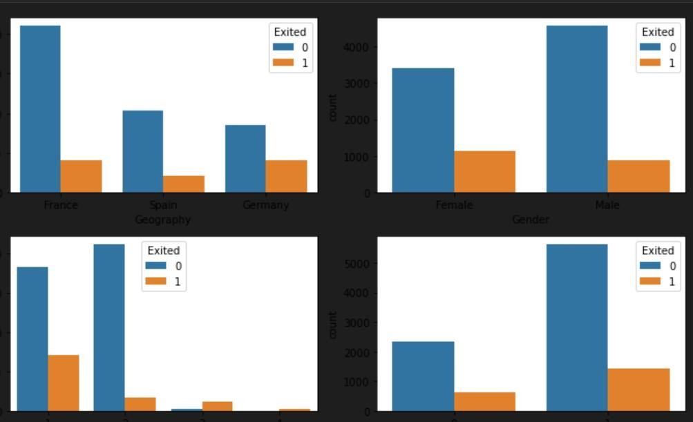

# Question 4:

Perform descriptive statistics on the dataset.

# Solution:

df.info()

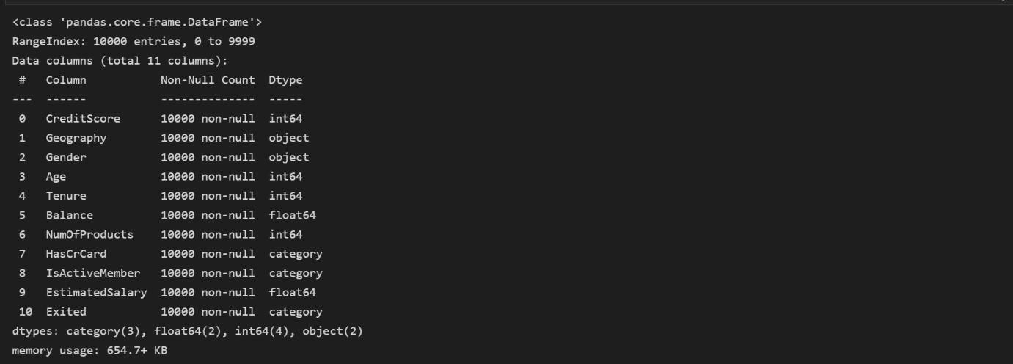

df.describe()



# Question 5:

Handle the Missing values.

# Solution:

df.isna().sum()

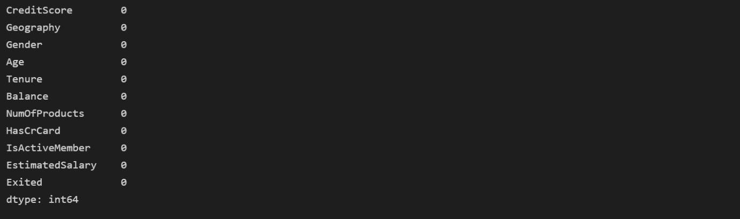

There is no missing values in dataset

foriindf:

ifdf[i].dtype=='object'ordf[i].dtype=='category':

print("unique of "+i+" is "+str(len(set(df[i])))+" they are "+str(set(df[i])))

unique of Geography is 3 they are {‘France’,’Germany’,’Spain’} unique of Gender is 2 they are {‘Male’,’Female’} unique of Has CrCard is 2 they are {0,1} unique of Is Active Member is 2 they are {0,1} unique of Exited is 2 they are {0,1}

# Question 6:

Find the outliers and replace the outliers.

# Solution:

Checking for outliers

defbox_scatter(data, x, y):

fig, (ax1, ax2) = plt.subplots(nrows=2, ncols=1, figsize=(16,6)) sns.boxplot(data=data, x=x, ax=ax1)

sns.scatterplot(data=data, x=x,y=y,ax=ax2)

box_scatter(df,'CreditScore','Exited'); plt.tight_layout()

print(f"# of Bivariate Outliers: {len(df.loc[df['CreditScore'] <400])}")

# of bivariate Outliers:19

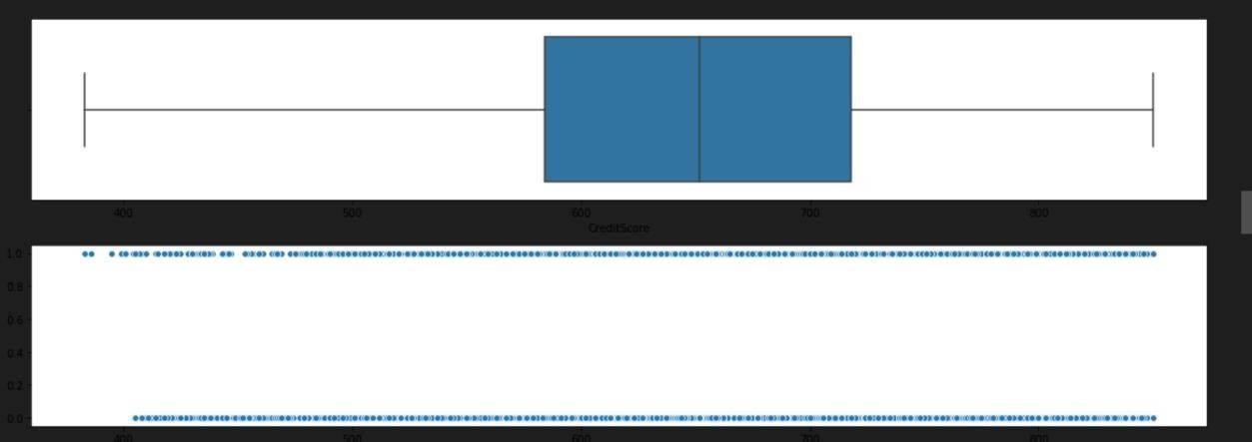

|  |
| --- |
| box_scatter(df,'Age','Exited'); plt.tight_layout()  print(f"# of Bivariate Outliers: {len(df.loc[df['Age'] >87])}") |
| # of bivariate Outliers:0 |

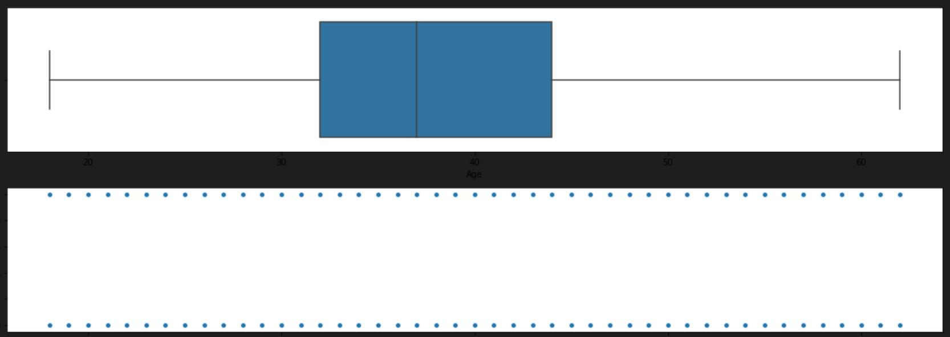

box_scatter(df,'Balance','Exited'); plt.tight_layout()

print(f"# of Bivariate Outliers: {len(df.loc[df['Balance'] >220000])}")

# of bivariate Outliers:4

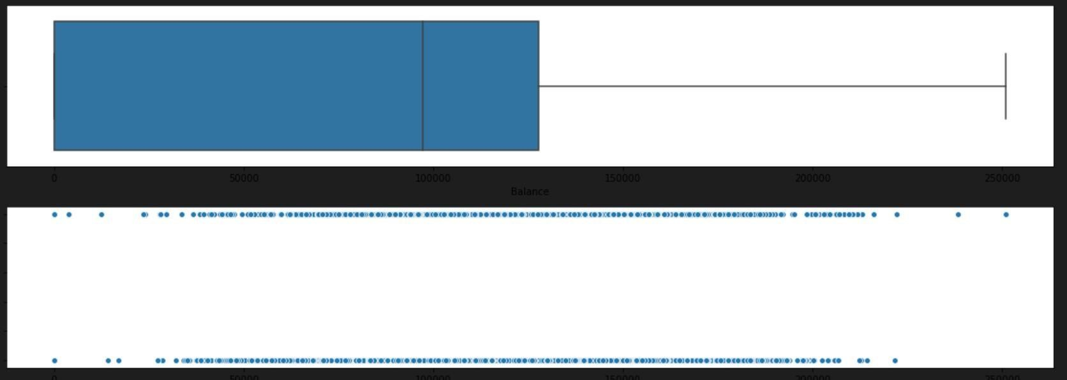

box_scatter(df,'EstimatedSalary','Exited'); plt.tight_layout()

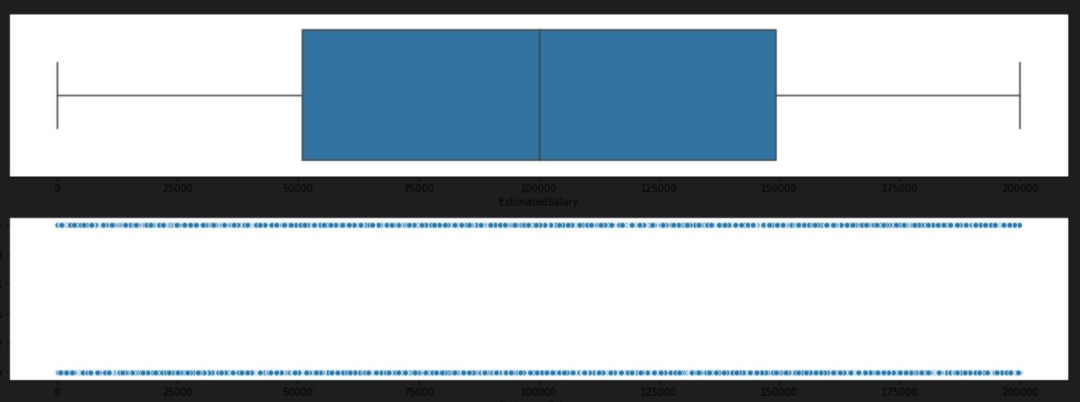

Removing Outliers

foriindf: ifdf[i].dtype=='int64'ordf[i].dtypes=='float64':

q1=df[i].quantile(0.25) upper=q3+1.5*iqr

q3=df[i].quantile(0.75)

iqr=q3-q1

lower=q1-1.5*iqr

df[i]=np.where(df[i] >upper,

upper, df[i]) df[i]=np.where(df[i] <lower, lower, df[i])

After removing outliers,boxplot will be like

box_scatter(df,'CreditScore','Exited'); plt.tight_layout()

print(f"# of Bivariate Outliers: {len(df.loc[df['CreditScore'] <400])}")

# of bivariate Outliers:19

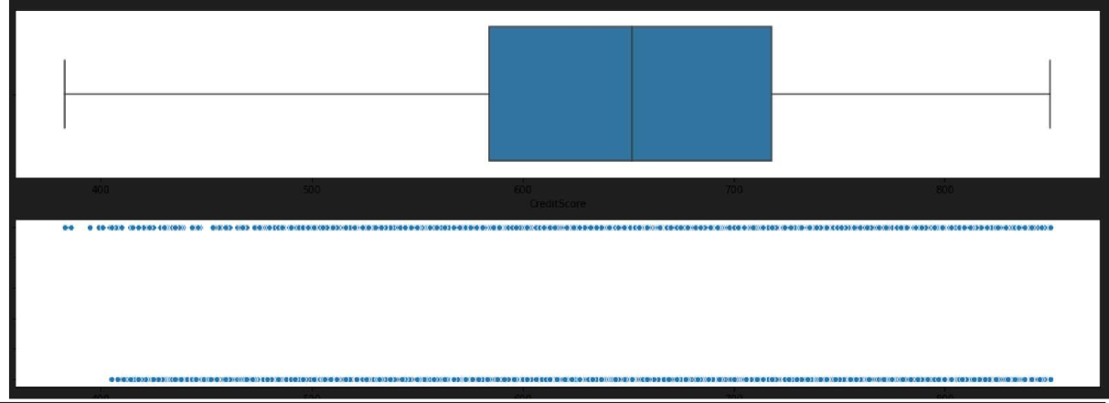

|  |
| --- |
| box_scatter(df,'Age','Exited'); plt.tight_layout()  print(f"# of Bivariate Outliers: {len(df.loc[df['Age'] >87])}") |
| # of bivariate Outliers:0 |

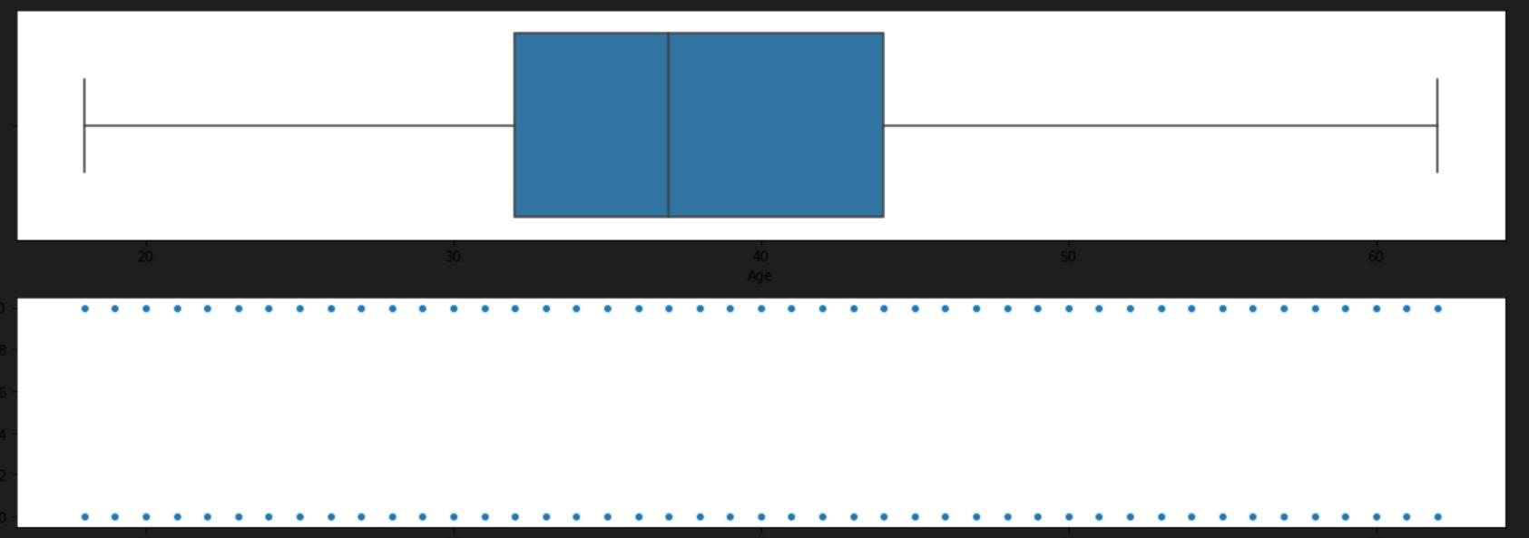

box_scatter(df,'Balance','Exited'); plt.tight_layout()

print(f"# of Bivariate Outliers: {len(df.loc[df['Balance'] >220000])}")

# of bivariate Outliers:4

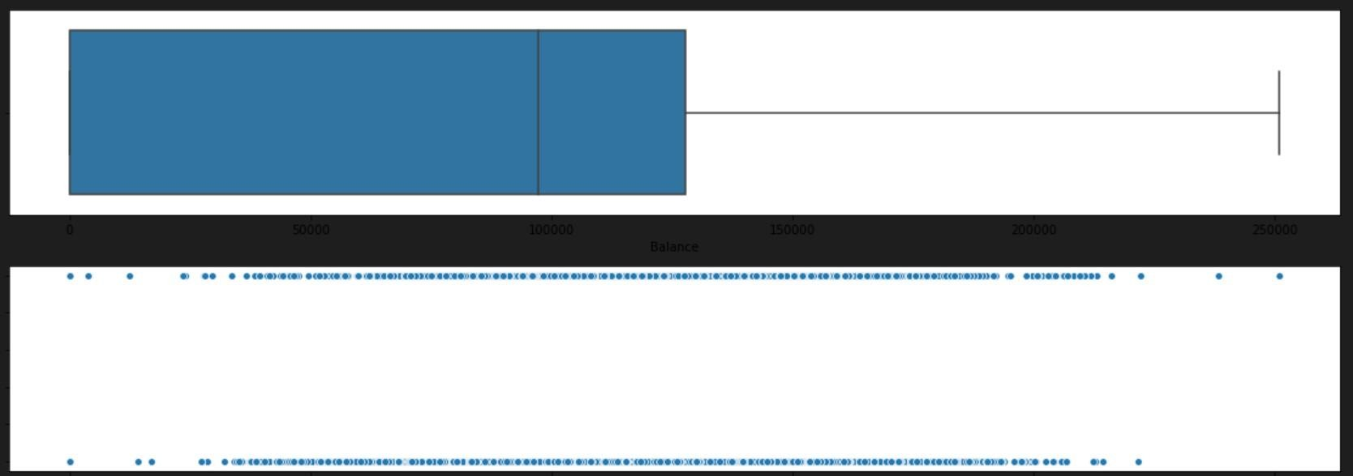

# Question 7:

Check for Categorical columns and perform encoding.

# Solution:

fromsklearn.preprocessingimportLabelEncoder encoder=LabelEncoder() foriindf:

ifdf[i].dtype=='object'ordf[i].dtype=='category': df[i]=encoder.fit_transform(df[i])

**Question 8:**

Split the data into dependent and independent variables.

# Solution:

x=df.iloc[:,:-1] x.head()

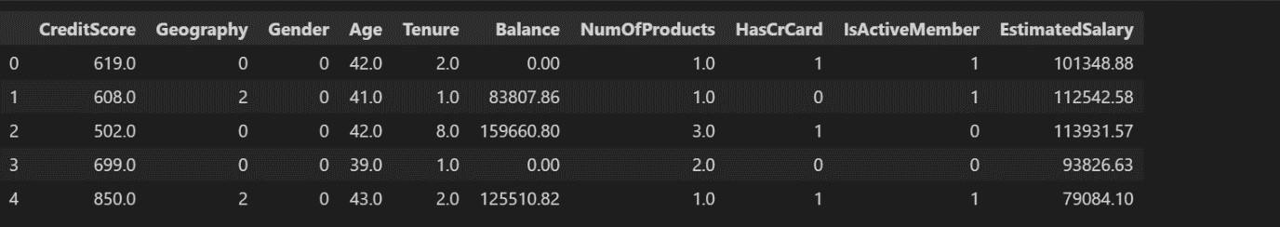

y=df.iloc[:,-1] y.head()

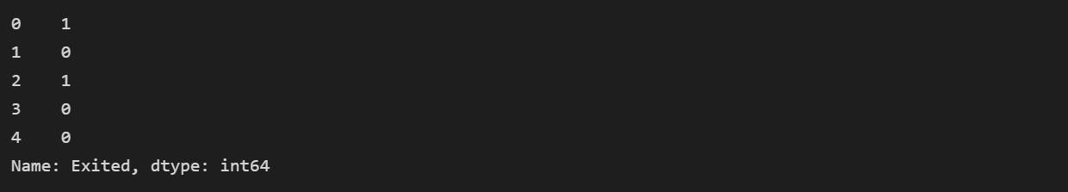

# Question 9:

Scale the independent variables

# Solution:

fromsklearn.preprocessingimportStandardScaler scaler=StandardScaler() x=scaler.fit_transform(x)

x

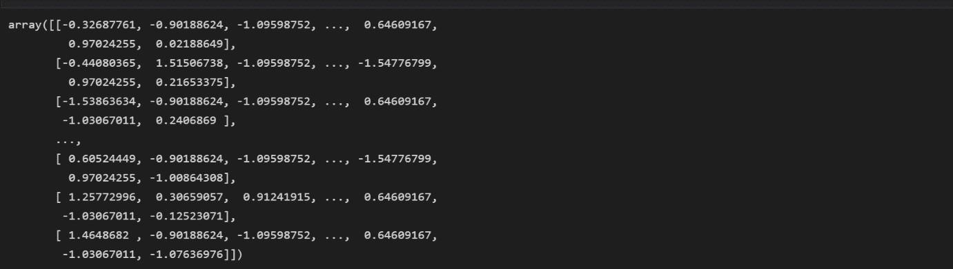

# Question 10:

Split the data into training and testing

# Solution:

fromsklearn.model_selectionimporttrain_test_split x_train,x_test,y_train,y_test=train_test_split(x,y,test_size=0.33)

